The Shalom Report

Authoritarian State or Inclusive Democracy?

21 Things We Can Do Right Now
[Eric K. Ward is a Senior Advisor with Race Forward and Executive Director of Western States Center. He is especially known for his analysis of why anti-Semitism is locked into the heart of American racism. In two (inadequate) sentences: "Racists think Blacks are inferior; how then have they won so much prestige in America, culturally and even politically? Answer: Not by their own efforts but by the diabolical machinations of Jews to elevate them and wreck Western culture." This article was written before President Trump ordered National Guard troops to tear gas and attack peaceful protesters in Lafayette Park outside the White House, so that he could make a Caesar's walk to St. John's (Episcopal) Church. He was intensely condemned for this act by the Episcopal Bishop of Washington DC. Inclusive democracy or authoritarian state, anyone? AW, ed.]

By Eric K. Ward

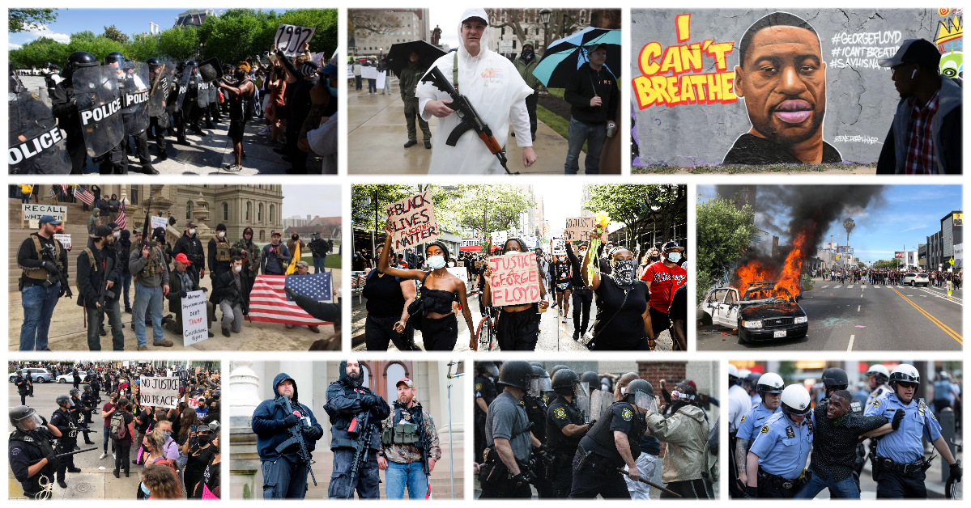
I understand the rage. I was in 4th grade the first time I was chased by police. My best friend got caught; I did not. His life ended up very different from mine, in part because I ran faster than he did.
I understand the rage. I lived ten blocks from the Signal Hill Police Department in Long Beach, California where Ron Settles was found beaten and hanging from a noose in his jail cell the day after his 1981 arrest just a few blocks from my house. Two years later, I was 17, on my bike, near that very spot. A cop pulled me over, put a gun to my head, and said, “I could kill you right now and no one would care.”
By 1992 when a jury acquitted four officers in the brutal beating of Rodney King, I was a student leader at the University of Oregon, helping to organize protests in response. Within a week, I and other Black leaders would be hiding off campus, unable to go to classes for fear of being served by a grand jury summons. In 1999 I was among the first wave to get pepper sprayed and hit by bullets in the Battle of Seattle. Later my work in philanthropy gave me the chance to shift institutional resources to fund grassroots infrastructure to challenge police brutality, through the Ford Foundation and co-founding Funders for Justice.
Engaging in disciplined protest and systemic change doesn’t mean I don’t understand the rage. Months after starting a job in philanthropy, I’m in my fancy suit in a line of people exiting the train at Grand Central Station. A white guy pushes me out of line. I push back. He comes after me. I lock his arms down to his side. Through the music in my headphones I hear him say, “Let me go. I’m a cop.” I release one of his arms so he can show me his badge, if he has one. He pulls his badge out from under his shirt. I let him go but I’m furious. I keep yelling at him, waiting for the police to show up en masse. I’m so angry I don’t even care. If this is how I die, I think, this is how I die. No other cops come and I proceed to the office. Most of the folks I work with are unmoved by my story.
So I understand the rage. You follow the rules and yet injustice after injustice just keeps on coming. But even as I sit here in a rage that makes it difficult to be rational, I can see that there’s more going on than the language of the unheard, as Dr. King described rioting at times like this. There are accelerationists on the right and the left exploiting our rage. Trump has tweeted his intention to designate antifa as a terrorist organization. The distraction of chaos can cloud our view. Which is why I have to testify to what is clearly at stake in this moment.
America is on a precipice. Whether we go over the edge into the abyss of a full-blown authoritarian state or find firm ground on which to construct an inclusive democracy depends on what we do right now. We need to be clear: every word and every action has consequence.
This is what I see today, from my home in Portland, Oregon where I pray my neighbors’ late-night loud music doesn’t bring the police to my block. From my work with Western States Center and Southern Poverty Law Center, responding to the rise of white nationalism and a far-right authoritarian state. From deep in my bones, where I’ve been living the reality of police brutality my whole life.
This is what I can point towards, 21 things those committed to inclusive democracy can do right now.
1. Recognize the precarious moment that American democracy finds itself in right now.
2. Honor the grief and anger that the public is feeling over the recent lynchings of Black Americans, many at the hands of law enforcement.
3. Understand the culpability of elected officials and senior law enforcement who waited until people were at their wits end (protesting and rioting in the streets) before taking the issue seriously and taking action, and who now stand by as the police riot in cities across the nation.
4. Condemn Donald Trump’s call for violence and demand that the U.S. House of Representatives and Senate open hearings immediately on the President’s unlawful incitement of violence.
5. Be troubled by the seven people shot in Louisville; the 21 year-old shot and killed in Detroit; the law enforcement officer shot in Milwaukee, the two law officers shot in Oakland, one killed.
6. Raise concern about the number of vehicle assaults against protestors by both law enforcement and possible vigilantes, a deadly tactic we remember from the protest against the Charlottesville Unite the Right rally where Heather Heyer was killed.
7. Decry the disparate and disproportionate policing response to the protests of police brutality in cities around the nation compared with the hands-off response to “reopen” rallies where armed white men shut down state capitols.
8. Acknowledge that white folks (rioters, not protestors) have again and without invitation, hijacked, sidelined, and distracted from Black communities’ leadership attempts to stop Black lynchings in America.
9. Demand that law enforcement prioritize de-escalation and that all violence against non-violent protestors cease immediately.
10. Build the collective memory that law enforcement has a long-established track record of disproportionate response to social movement protest that comes from the left, and of employing agent provocateurs to incite violence.
11. Insist that police not equate property damage with the taking of a human life to justify state violence against protests.
12. Lift up the peacemakers, those like Erika Shields, the chief of police in Atlanta who walked the streets with protestors, talking to everyone; Ruhel Islam, whose restaurant burned in the Minneapolis uprising and said that wasn’t the most important thing; networks like the Movement for Black Lives (#DefendBlackLives #DefundPolice) and local NAACP chapters (#WeAreDoneDying) who are calling for concrete and tangible changes to systems of policing.
13. Raise alarm about the activation of national guard and military units, martial law, and states of emergencies, and the idea that those opposing fascism could now be labeled terrorists.
14. Condemn accelerators on both the right and left who glorify and center violence over justice, othering over community, divisive ideology over common-ground values. Demand that all parties cease engaging in violence and the targeting of civilians and their property through arson.
15. Demand that cities and state governments launch independent investigations into the deaths or injury of any individuals in the midst of protests and rioting.
16. Call on cable, news, and other media to drop all pay walls during this time. Americans need access to real-time, fact-checked information.
17. Call on the United Nations to immediately appoint a human rights Special Rapporteur to investigate present-day lynchings of Black Americans and organize towards a Truth and Reconciliation Commission on policing in America.
18. Press philanthropy to immediately double grantmaking, for at least three years, to advance real equity in America.
19. Acknowledge injustice but call on all to restrain from a cycle of systemic and physical violence that will only escalate the rise of authoritarianism in America. Continued violence — from white nationalists, from law enforcement, and from the left — puts beleaguered communities in further danger and will contribute to the re-election of Donald Trump, which could end forever the dream of inclusive democracy that our ancestors fought and died for.
20. Bring together people of goodwill who believe the American experiment’s best days are yet to come. Defend inclusive democracy by using disciplined non-violent protest and non-violent direct action to demand justice and hold local elected officials accountable.
21. If you believe that Black lives matter, support the goals being established by the Movement for Black Lives. Respect the Black leaders who have lived this reality their whole lives. Educate yourself and others on the connection between police brutality in America and fine and loan forgiveness, universal basic income, and other forms of reparations as outlined by the Black-led movement for justice.
Do one thing. Do them all. But take seriously — and warn others — that the attempt to create an inclusive American democracy is now on a precipice. Words and actions carry real consequences that could drive us over the edge and to a point of no return.

